Ex.no:8 Date:10.9.2024

AIM:

NMAP TO DISCOVER LIVE HOSTS

To study Nmap tool using TryHackMe platform**. TASK 1 – INTRODUCTION:**

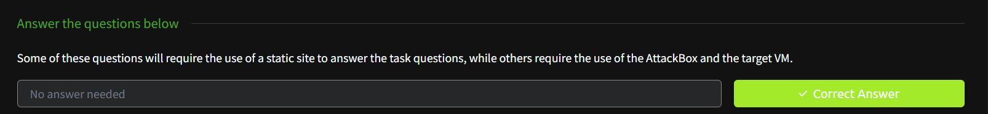

TASK 2 – SUBNETWORKS:

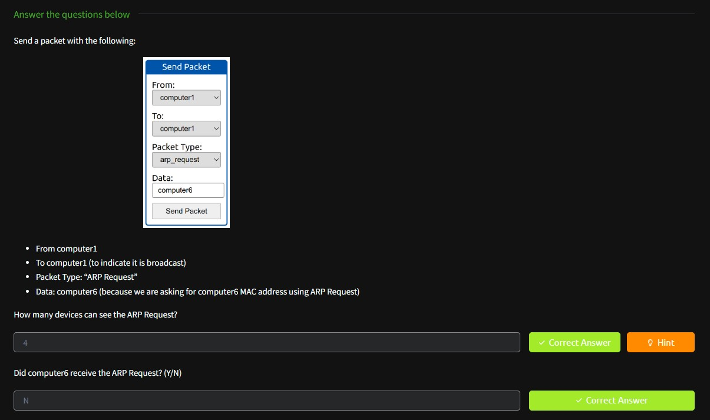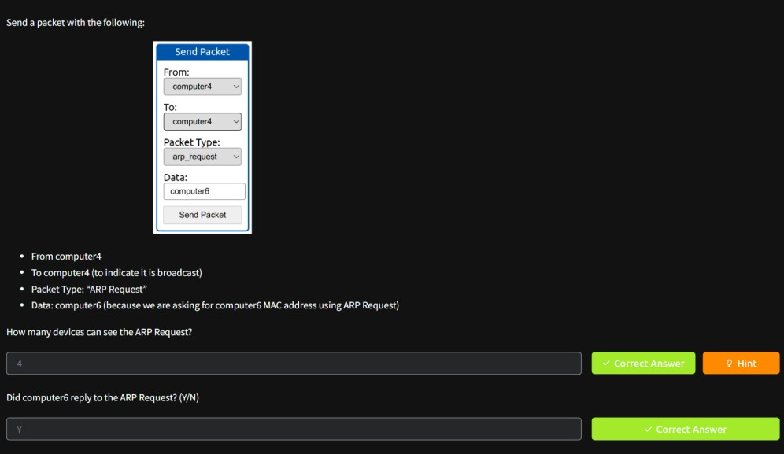

TASK 3 - ENUMERATING TARGETS:

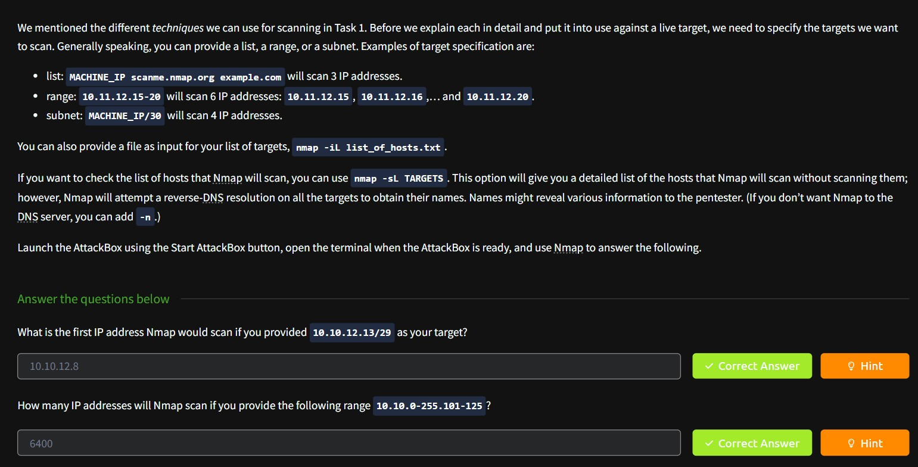

TASK4 - DISCOVERING LIVE HOSTS:

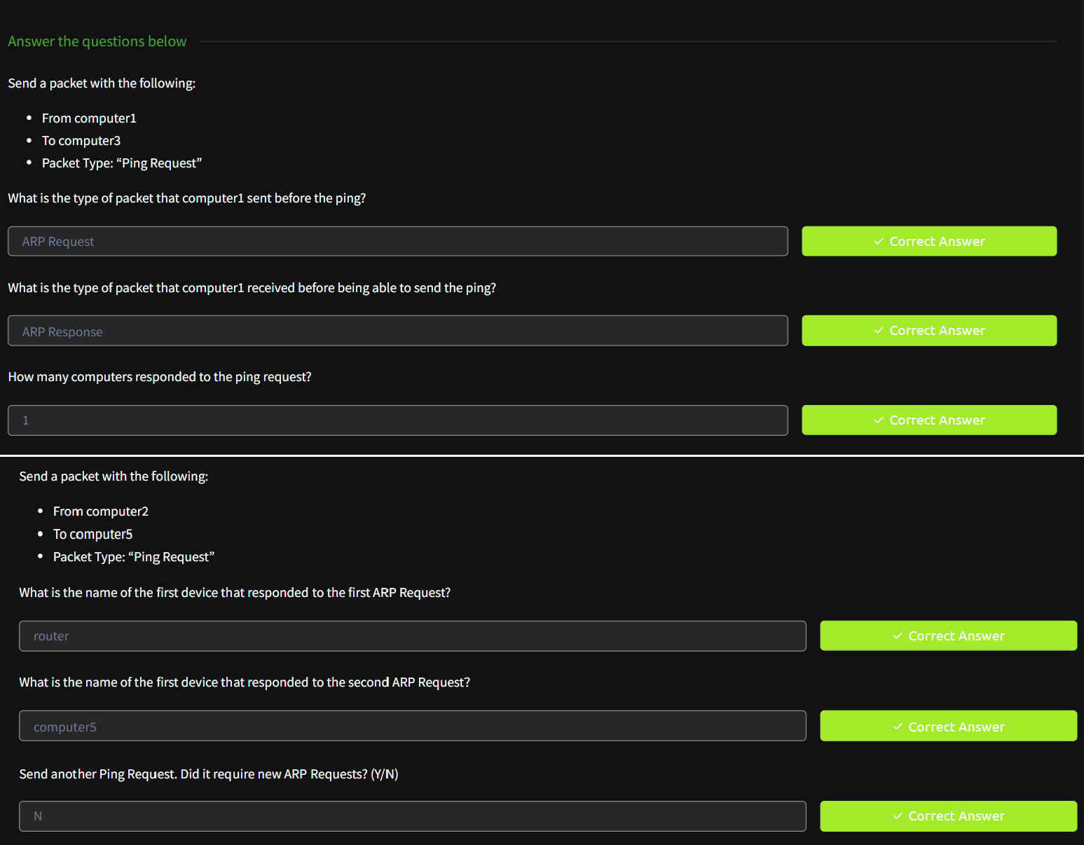

TASK 5 - NMAP HOST DISCOVERY USING ARP:

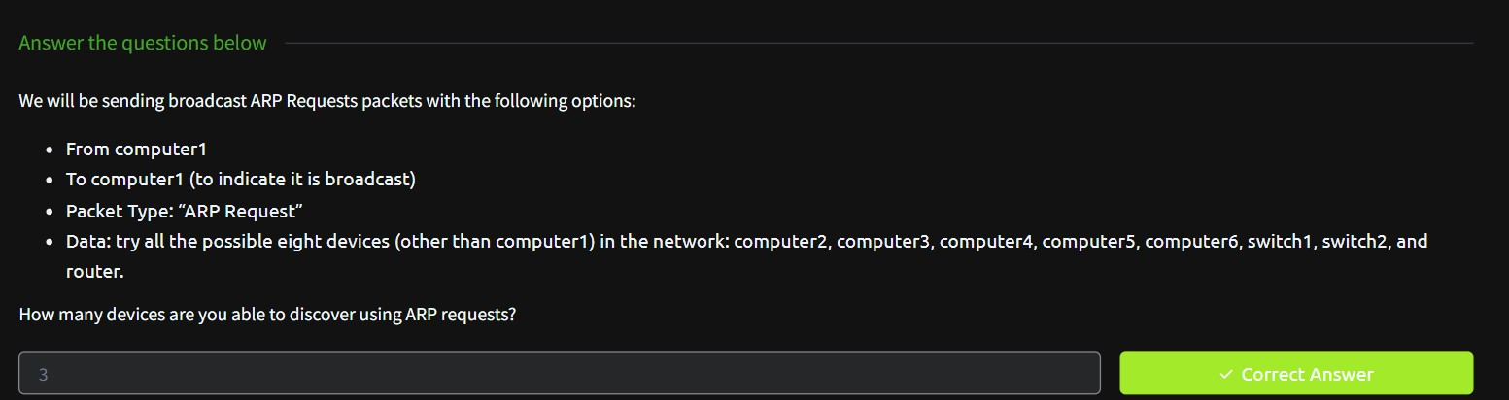

TASK 6 - NMAP HOST DISCOVERY USING ICMP:

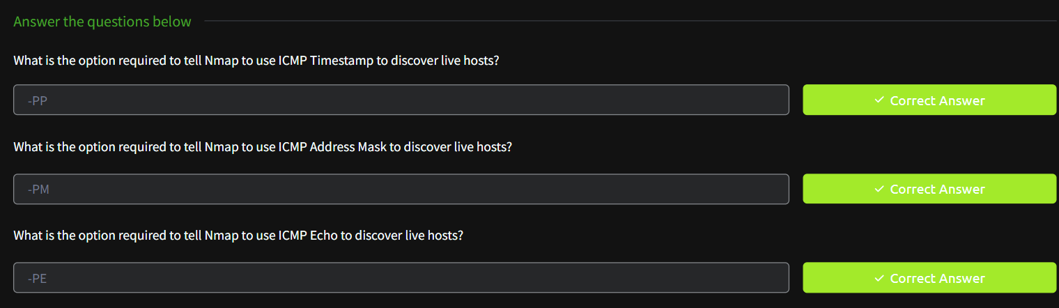

TASK 7 - NMAP HOST DISCOVERY USING TCP AND UDP:

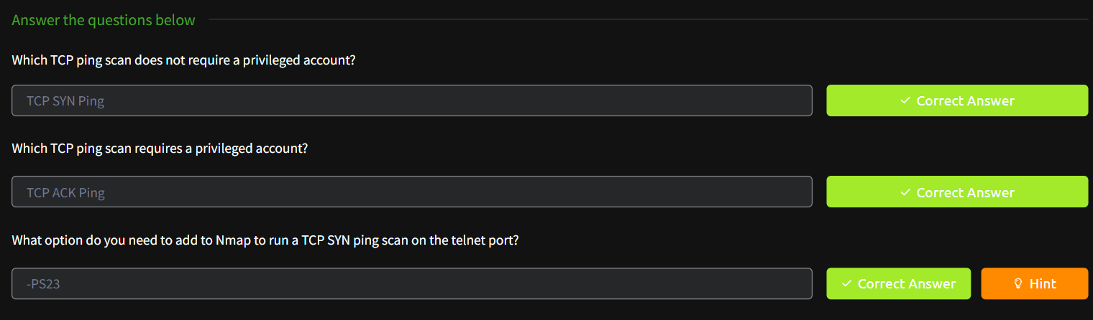

TASK 8 - USING REVERSE-DNS LOOKUP:

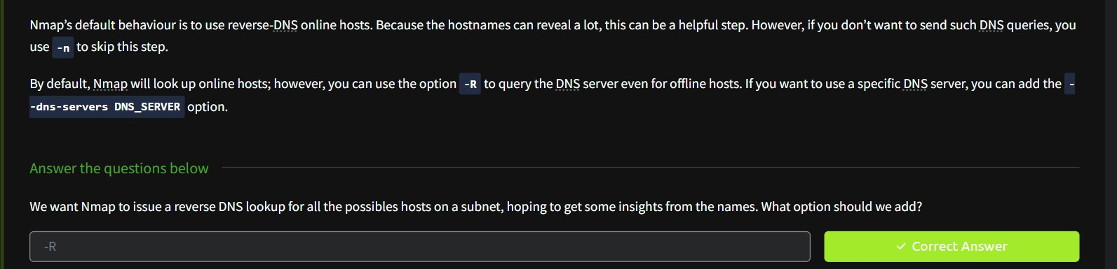

TASK 9 – SUMMARY:

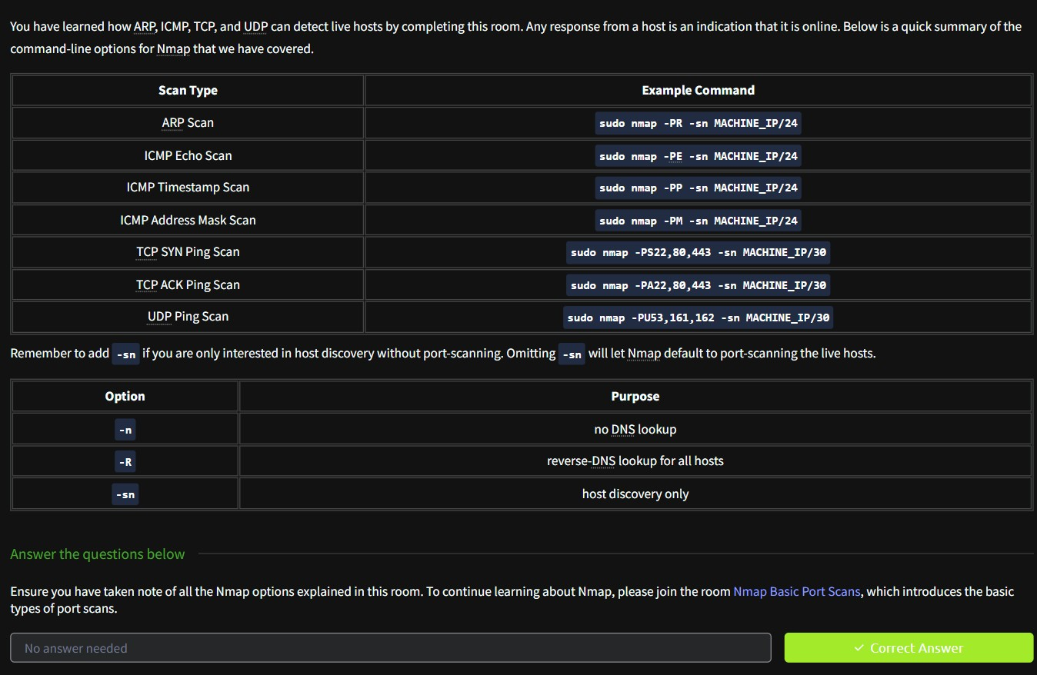

RESULT:

Hence, Nmap to discover live hosts is studied.